{s
(<&?n; iifu q-J
ffi ]#
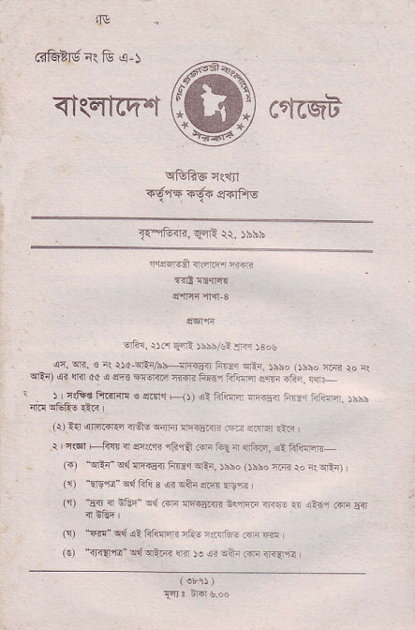
<T(El-fi'.t c'f6qt
qffie-E{fi
Fqt"Fr a-!tT e|$lF]s
lC{-{I3, E4l lr, )bbb
eft1. )d sni ibshtlt:ird ro!
r-, r, ^{: r?'-} i-,.
'l-i\s@do{*-ET'n'f,@-.">/:r}r'.'nr
J,-cri.€ Fffif4 € fr- -r. ,
)', |@.?;'
J ^{'16 - '18} r _{i*} ^{- --?} r ra. ^{.r=i} . j)?,ft _{G)} ^{_qFr" qd} rlriiEir _{h4ir} ^{qin. rbbo} _{Onio} ^{:fi} _{ro -i} qian) ^{(i)} _{Er!."r&} ^{qd} _{Fii'i 3} ^{qi ea-n erR} wa l
^{(r)} E{ T _{tji6'} ^{qd} ffi sr{ri< iqffi ?F:- < !a4r ^{m} Eq
_{F)} ^{_m" qd} ai _{ff{Fn} ^{'Ii-} -iFrE- _{r+irr} le
(E) _{?raii"} ^{q{q.E} _{n} ^{j! ii iiii} ;ira ?i.!rri
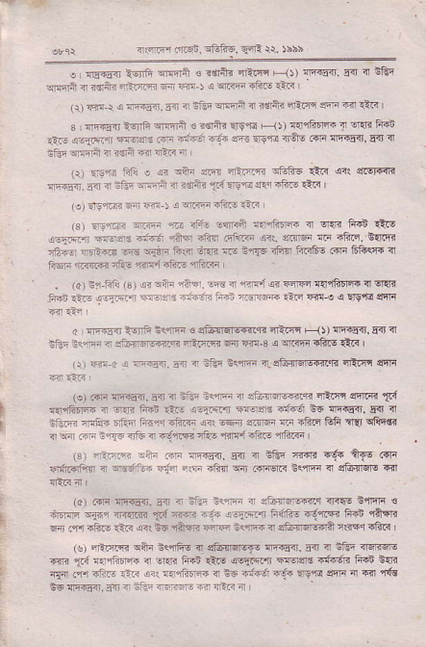
_{4€@r.{raii.} ^{iftfr-g.} _{€aR} Q. )srb
! L _{d5.r{ :9fiF} ^{oFrrn ! rdn'. 4Lq F} _{1t} ^{qF.5<.} 5.r rl Eliq ^{qEln} i ?s"n fliffi F _{ffi-) a} r]rir il?.s €r?
_{li)} Ttri-r < ^{;iFiEni.} _{sri a ein} ^{qrlqi} i ?sai -ftl6 m -ir lii s {F{fi _{l6nE} ^{qcqrnt} _{€ r,Jlit.} ^{qst} _{nt} ^{E?rh!@} '{ dr.ri Fri _{ii:.-} ^{(-aF.'i .eqe} r ^{r/€ir} _{1@} @ Erg.r itoE .fii rftisil. E{t { dn6 errn r' ?d'ft n {E3 --l
1r) EEr lifi ! !i s?r4 _{eF4} ^{qri'm} !tuj?6 itr _{o<1} q.sF{r !]I.fn. 5ir .r nGi unan i ilrtu ti Ers. @ !.r -to- €in I (.)En'nnr o 4 i ! dr!-'.5F ilF r
_{ts).rffi} ^{irr} _{"!3} ?fi. -1Tnff Fqntr< { ^{q{i} 1i4n tE ^{'!I-} F: 4 _{ffiF'+F} f,.@ _{r?-} ^{-Fi.:d} .!ril zr? _{i?} qr:.Ttrd?ir.ri_46{ F@ r,rir.i _{nF-} ^{,rir1} _{FFa!5} 'nfii.F
. (() n:r _{FG} ^{(s} ₎ !r siji .il-. _{!ft i ffir o? ffi {.11frDr4s} ^{q} lrdr _{@ €- ir9!.ir} ^{:Es1 -'.ar'?} li?- 4ffi _{tii Ftn o €} ^{qE4d} !!Ti
c lF5i asrin nc.riF € sGtr]qlqe.qt ^{4dia Flt !rFf5ar.} _{a{t} !l tr.r irF n d,5ijl:i::R.r. -?.4F 6a- F 3 a :n<qi ^{rtftE} rt" I _{1lr dr (} ^{j} r;:-n..i 4 njti i<@ i-qtumoFfr.{. {Et|r qqrr
(ol @ iF€4. _{5ri i iGr nqffi 4 arErfl.FfE} ^{qEd 6nqr} t{ rllrhlF 3r eaE li$ 1-|t _{a-h7E[} ^{.ffidrd} _{ntr'fdr} ^{g6 !]6i5<r.} _{&<J} <1 tEn rfFi r,,?r Fir{ -fii/F <ii _{t@} ^{gtnF} _{Fn iiiri Gfi lilr} qiiqsr , ^{r-.-:} _{n} 4 a 6iryfi' @ ^{dis"} "'wa
_{(sj} -aE'.2 ^{iiin} Fri sa5<I, Fir 4 Etuq {{iln igi ftJE Rr. Frffnri i r,.!i]:- _{Glir .rF..q{} ^{qir} .+|{qn _{i<'rF i €tuarqF} ql
(a) .ilr ^{rfisg{.} _{!-ri i ;:r neirri a} ^{gkl:i:j@r} ?'{to ieiqli € irffi ^{stir nrr'{iTi} _{Td} ^{ffi} _{"F} a.t@'li F,ifiE dgjE tut rArR 6.r .t ?toE ilti !* i6 cittr ffi -sffi 4 eftrE@A ilFq ?BR I
(!r _{<f.:|ffi} ^{qqii} i({fi€ il darFFF ^{lriiEnt.} _{5ir} tr ;Gq {Eri@ ^{i3ri} _{1.{} EirrftR { ^{q{i} iFn €.€ sbir,.ti{ ffi$€ -{6r< f.6n R{1n 41 .n -ft- .-r ^{!<t r{lin- ir eE 4f€6} _{16 w.li sqlr} al _{F{} ,ns tc !n 5ir. _{5d} ^{q} _{i-} -r-rer. ai 4lc --i
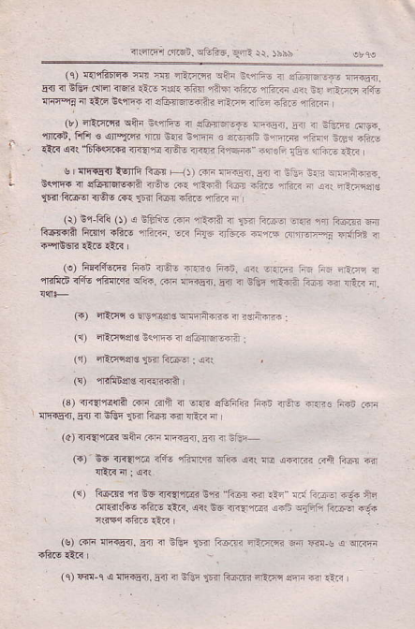
_{-.ffii rFi} ^{q-fr-..f-E ,i} 5))r
(r) {fiftFlq. d. s 4ir"ilr eijn nqirFau a .tuiFr-f- ^{F<E<]. g.r]} n lGE _{c<'rrrr} ^{qqri} €i. i1s. rF{ {i_F -tu- ^{2riiF} eii i. .Eft ^{nF} lrn-ai n AF EccrEi ir _{aja"Eirrcii} ^{qFF} a,En aj?.- 1F."- (r) _{<rlic.'ri} ^{qfu} iq,rfi- n etunffi i,-€.r. .i r nin ^{mn. 'fi.{b,} Ffi _{s} ^{qn-tm} rir;n tltnF { 4FFF t1;r.ai ^{4fijFr} -cr =fi- €R @! ^{'1iftq!"!} iFlrre ir6! ^{@{i ii€e rqlF} r:- it@ .?j
,! rlEqr] isnft G-6q F-.rt ffi r5..:!n_.-r ? -1; E i ffiihtu. i<,flFq 4 3ia{]qlc+la 4n- r"r .ff _{r-d nft-} qrAF n ^{jr] "-i:F$g} lm ^{RF6o n+c R.} _{1m} Es. ift- nriti :i (r) n,i-1ili ()) o $EjnE .iri dtirA { iF _{1i..@} ^{q-} rJ tus.< -ii fr4T{li ftlr'i slie f.i.ri. @ F{5 d,Fi -s .a1r-:i ?riFE i
, ", :F_.r5r& '
^{,fiFd} <fiE rFq.ri $i.. _{ffi} ^{qrElEri.} _{F{} ^{q} _{tftq} ^{,rffii ao} _{":i} .ir i C+) sra.F € _{wis4d} ^{qrern} maid+ffi
(!) srlrfl$i nsrr,F ? oft4qr{i
_{(jr)} ^{ql@srd} $.rli.@: €rt
F) nrFd4d {<1rna i
(3) <ri{e!ra cr'F 6a a -qR _{s1iff€ ffi} ^{'rr.i1} .jrr: {r€o, r+ < nGn ^{?r'a} F$r e rEa d
(4) _{ri{{rl@} ^{qft4 ffi !1--s..} _{5rr} 4 iEF-
(r) 6G _{T,qnF rfft .fiTn} ^{qk"} {ii e affi rr,} tin a qt"irrd<!
^{(i)} _{FsIlrr} ^{'n} i6 _{ir{{rqEr i'ri} ^{'tu@} @ ^{q6} rd?c-;.Aq ffi@bere 4 ir.ri,@T ! t.r:-.+n:4--
rssr.tue ft? '
(s) 6F !rF+5ir. 5ir ^{i nftq} _{]'i} Fff ilr':F - m,s < r!Jz@ rfiI! Qir I
⁽ 1) 4Td-1 ⁽ rr!T53. w ^{a nEi} _{te 6iffi} ^{qFis} .F cr .i.j
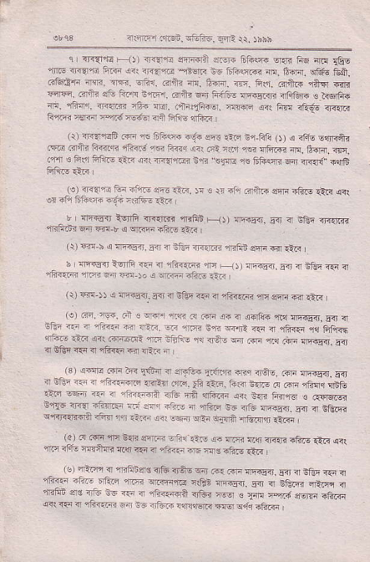
{.rf 56i. ^{Ttn-.} i-; i rbbb
r r o'T{rn- qr) ir.{"n ^{ar*'il} _{"--} 6fr* -.ffi
1n 6 <r<lrre ii.-n a.i _{r{EE} ^{jteF} _{-c} ^{jiilsc.?r} d. 6@. ^{o6!} EA. _{.i@'F} ^{:rn.} ffi. ^{-fi{.} Fil? a. ft'n. r. 6ir. _{6r+.r} ^{qftq} -in ^{-.ffi.} F,t .€ ri.'E i.rFr. 6+a @ F.16- r.iaE@ afqGii. s ffi. m. rfiqr. n .R 16{ d<r. ..h:lh€. ^{'ijiffi} a<1 Frnr ifto i]r!r@ _{F"l|F {dr@ rvJe-q} ^{qii} _{Fli!} qtu<
t,. _{-"afi a} ^{-.+ -. ..:} "% ry sr ?d _{(r,} ^{j} dtu E"rq6t _{.ar ?+r} ^{+ar ?' .} :. ^{.ei} rar? ^{n.} 2.?. @ .'r'i € iirl ^{ii'G} _{aa.j} i<i ii.iqiF3 n1i "<-{cE ^{.r.} 61iw 6{ n{.r{" aq8
_{1!)} ^{<<O"a r"o} _{"o:J} ^{u*} o-_ r! ! _{ri} ^{efl FftF @ta tstu-} _{€rr} qrr
!r ifi ^{6ftsF il:n .i<tse} €d
^ " r-{r+ ^{}"-5} @"!* ^{,rrli} _ ^{j, naqE?} _{,4} 4 ^{,-5r {n-@ .ffi} 64 h r o ^{'r..'n} i-@ 1-t" (t) @ ^{n a nFrd-d.} .6 a nftn n .r.tri nFftn eft @ €6 l | ,E€?}Fl-G{'.,@ - j.re.q?-a5e?ri4 ^{1r?.l;4"@n@} ,aan.ft-.i., I
(i) rfi ^{$ e !F.sir-} na { ifrr _{<ri a} ^{qti{..q} rr ^{erF m} rlR I ^{(o)} {-q. 1q4. an 3 ^{!e} _{rrR} ^{({} _{r a< i} ^{q.llt r1< n--5ij.} Fil T !G' @ n c.:i'r€ ra r?i. !E 1@ i.r ^{rfli} rE{ { 4?<{i 1{r FFi.j _{ea *} ^{qi6,-r-i-} _{F.,,,'} ^{-*r} E ^{F-rFEEn Tn q} €Gr {. { ^{,rli-n{r} _{@ {-6} :i _{--(B)} idla ^{@:i zE3} _{E6\} ^{a !rT,,iq} _{"_nn,E} Rr ira.s. ^{ri! {c€q} Eir
a lrei _{F 7} ^{en<5{F.R1ld .rF_} _{IF} 1ij. ft5l tuF d crF.j?n.i lFE _{€6} t6 iF ^{n 1i1,-q?} .,tu 6ii d?.n ait nE ft{1€, € ^{..lrFc r3r} tr_f3. ^{'- 63} r ^{!F'55a} _{5_.} 4 3.:rB _{'' rad} ^{,-.Frj} ri*_ ,
lo]!@+?a:F
_{ta ?r- +TuqR} ^{qq} @ a .tF tu F ! ^{.ftr} i-c ,
₋ l!) 4ti- ir rYFndrd _{<'16 3T+q} ^{q{r .-. @ alq€{,} _{!ir} ^{? o1tq .€} { _{{F} ^{qrirF,rc} lrB? ^{;rqn€ni.} 5.r I Etua _{a-.r,,} q
fiFn :re irft i. _{-ir ir} ^{-ffii} irtuj ^{r@ €} afi ra erq,F -h.in o<r <€ ? r-r4<.@ ^{d i. ?ftF} lia&rF _{.Eq} ^{q{.i} -6F
{r4rF r dcn. ^{E&fic.} E{R !r. rhbh
te, :4 fiPa- ^{- %-} s..,@ ^{d.'r65.. {} " : -Fr. 6411 .r- _{n .."} ^{--fac} @- ₊ ^{a,aE,} . ^{q?- "} FrerR lTtr EriqglR ^{qrm1r} ft- €rq a?F En m srait &E,j { ra I (r) nri T@a r'.q@. EF-s 4 Gr,ria;F {.fr -:.o s{ft! F-tu-{. _{sa} . ^{r,.y} a ^{tr} _{"t<a} ^{at--,} n
_{FF.} ^{r'n'E-Ar,@} tr=@ ^{r1r3 l@} r,-. . ^{TFn} r G6a{i _{i-rFr'E nr} ^{qrm} _{..ri} ^{q1E} a+r.n-riiE{:iE !rFF-.ti _{i.} ^{-F} _{turF} ,i.ji
_{,5,} ^{.@"?b} r.ft.. @ F. .
^{,ttrr:iffi} 5T{ ^{s1 { 6lr} r rtrr,---.,%..']rm €i {, €-rF@ rr<lrfql .1r ifr4l rqr inG
rlo\ ^{156{ ':ft c5} _{r} .€-F r4srriilr.-?6rfd-r qr+tFd"+.F?, .n"-ritr,
etF Teli- _{o16T!:} 'nn ^{?Ff} 11r riz
".., -,r;l
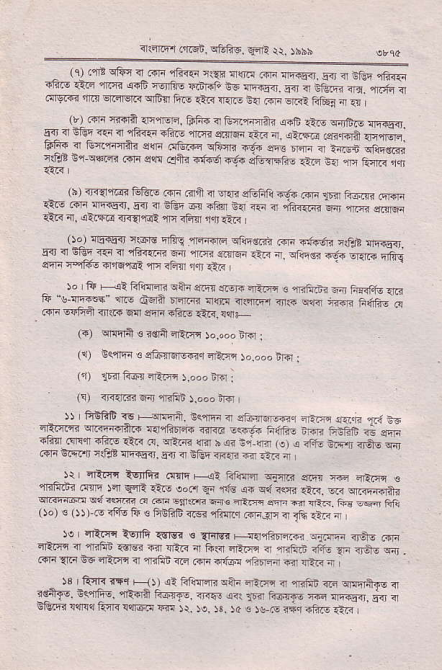
^ )o ii _{Hi Rfffi} ^{qiiJ} .m .r-ri oaF c mii.rr ^{F Fkf.tu rE} E"!.rc* ^{qrd+6-'.'3 14_ r4rl1.} { m ^{-t]n4 ?i.R} fl lqF 4ft- _{liri} qo-
_{(")} ^{qqrn} _{€ r€R} ^{q&n b.do! iro} I
(i) n<rl'n € sE-s5r<q ^{4lF} )o.ooo ^{irir} i
(r) ^{i]F{ R6q nRF} ).",";ro
_{ls)} ^{:nianTi} ir ^{rF6} !.od. tF
₋ r) f'ifiF < F+qft. n<rF T ituFF-r _{i-F} ^{q"i} 1.i r ^{4br} _{.n} ^{-?-et?.. f'@4i} ₊ ^{..-,)} _{:>c:} ^{.q"?. ra} ffi 36?[ trtut ni55i. 54 ? :]:r ^{4<.ri} "? i-. i ₋ ^{r) tlr IFC_r} _{ria-} ^{.@ a} _{" {-} 4
⁻ d4n- ^{(,T!} ₎ ^{' qf3:n, roc} _{F} .- ^{,b ..} 11 _{4.} ,(r ..r:vr64n _{ffi.!!} l-itr
^{,ro,.:,.} r dr1? e. _{rfrntrr} ^{- 1_.} -ri+ ft:
5:, ..F d- 6F € qF@ D."rlrjr;F
_{"3r, {} ^{."-.,2 @ a -} _{Fa} ^{-11 n,} . @ _{{F} e6 <Rqq 4 {rlni G _{.Frn} q.'o{ ^{qrirF q} _{nti} , _{)B} te o? +r' -) ?,ilr-- ^{iA" F- {} _{"--J 4-} ^{J:rt,} . _{"gi., n--r,} ^{.-t} +r:]iir
^{qEm} &rrr! Ea< r.nq,ir m )i. re. 13. )4 c )! F *q drr €.,<
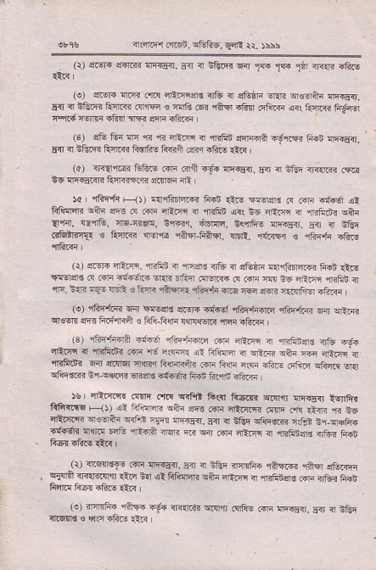
^{i.:.m rr-ii. trf!1id.} 14: lr )ii\
(!) fur. srd'{r !rEiE{.5r < neirj ^{w} _{1@ 1@ 1il} {i{" ift!
(!) s'-6ri ffi cril 4Em{€ atu nl _{sEiF} ^{q.ri q€qitn} lFqir. _{5.l]} ^{q} iGiF" Fl.nr .{r@ ts nfc ili raF -F{ _{.rriza} ^{q<i} ftlm FF6 rad'jtr$tu .m crFituF
⁽³⁾ _{sE 16 F fi n} ^{qEE} _{i} ^{'mftB} ffil i-yrR Fir aF6si, E{ 4 ^{Eftr} Fj@ fis.6a frnii €iq -h.o Ar. I
(d) 3Ft@ lntu;i ^{r aS r.6. !E€o.} s{ { EI-i nF.rm r@ d5 rrq{Er"'? ka'r@"ri er:M ml ,
)a rfiFfi F-i)r {.?frdfl@ Fin _{rA-} ^{,@d!} F Fri ctur oi _{trffi,.r} ^{q?n} @ d .frr. ilF . f;iftD {rt i6 {EF i rrFrii? o&i _{{fir,} rd{E. 46 *{F. S'ri1q. ^{irffi. i<,r,it6 xrEi5{.} !ij { iliq .iG-ftT € RrrGi 1for rirEr _{F+ir !EE.} ^{,r{hrq} € ffir,ti rtoJ
(r) erdr{ EFn. nfrn a ssr€ _{<tu ?j} ^{qGiF} s.nfoffi ffi ^{riiE '{Eer€} _{F ffi a:.'e'ri} ^{qrr.} ri,ai ftrF @ m ft E6 4im {rFn { _{F.:*:= rjl .1- i?F.r.ti+h} ^{qr.} ffi ^{?s} ftntrqitoTd, _{(.)} qFltF3 q-, :m4s e&r. i!ir14iEf{irrn _{1ffi.i lin} qiR ^{qlw} ffi li.!+n a r _{ft&-Flri rnrcr.<} ^{'lllrn} ifiF
(3r 1h-6na -ir6 ^{rEeiim} aF iftr a +.fiiers nfv f@ EsiE ? r+r,e
^{'fiiF.i.} 64r _{lrnrqi} ^{qnq} Fs.riii m liri nrF nftE _{trfiG} ^{.cft*} q{ ^{qiiqo]rr} _{n.i} ^{q1@} E|rqs .{.l'ii FFn ftd <i'F
_{5s} qR.nifr ^{q9q} _{.ni!} ^{qrF} _{Frrl ftcarr} ^{q.lr,r1 w"€{} ig'Ifrr Ffiiffi ! ₁₎₎ ^{qi Frtun cltr} _{sqrs @} ^{qrtia.R} ffi cE _{€n} ^{,E} E6 _{cfti@} ^{qso?ra qiFd} _{.{q} ^{'fi-!ir.} E'{ n ^{cGr atie@R:rfi} _{bi} q+ha _{rFtun} ^{q{id} FG a-ffi rr _{B} ^{qi} _{ffi nrt-q} ^{q} nhnqa 4iii 6ii
(r) ^{?lrqirst-} iiri ^{r1FFsil.} Fd . iltq nrirFF rih,rri fi,fi ^{etuffi q{an} ir<.Erlrr -i.i s{l {! tr@E sAri aF]5i { ^{cFtu$} idfi rrf6i tuR
(.) mElic .iFn i- _{<i?rar} ^{qFn .qF- @ !F<Eri.} _{!q} ? EE llrqrnE € ^{qs} .ltrrE laF
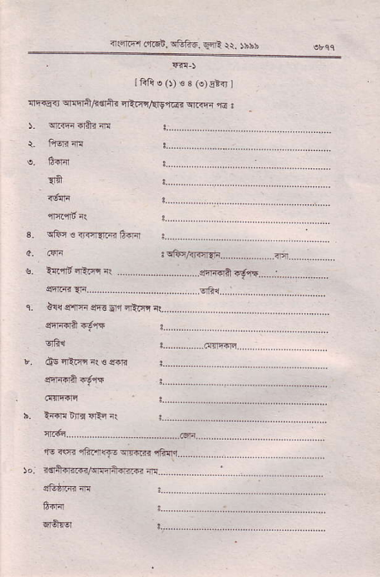
{.nriEr _{mFl,} ^{qffic.} Efi r\ )bbs
If{A ^{e} _{0)€e} ^{(e)E*{r} 1
_{{Eqn} q&rfl,agltu qlHr,tr9'l@* qRrF ^{,r!} !
{a
!s6'ffi
.. ... smrinlE9i!.._...:..................._
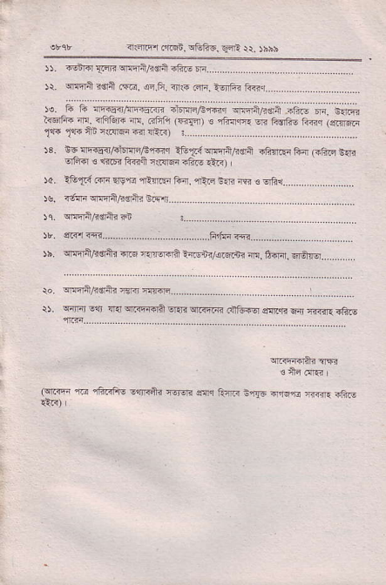
?lfier _{4'tci;.} ^{qF6.6, q{i} rr. )hhh
_{r).} .E?- :G- rnqr/.ri #
lJsnEiag:r@''r|'4'.fi'':+?@.|
)o. 6 1i {ri.3r,eFr6.< ii!m/e'"6i.r {mniFe,n i6.E F cerlEr t{5+b n fa?F ^{n../a",'.2F.€-tFqrt-r, !a"} r!--Ei, _{16 le} ^{Fi '.irIT} _{cT93} ......
r3. i6 ^{lrE{ir/,<iEFrEr,6s,€r} itul&.{qf@n,4€la iF{.!r F-4 (iftE b1lR srtsrd € _{"rtriF} ii<fi r!.{rEri ^{sliF} €c)
_{ro} ^{3'eTJ} _{@ aq --}ar} ^{ari. -ti?} d.E a e/r".... _{)u.} /rnn ^{ern6s+-} ry..
_{)b.} ^{qenhliitj} re.q ^{rrEr<il} _{hrsnj/q6l'n? e. O-rnl.} ^{qCF} ..
Jo. T:!i!d- ^{r€? ffi} .... .... ....
$. ^{q5ifi} E$ _{4{} qrnida ^{q.R qr.4r@ r:iFfq} dq.!E E:rr s??1}fiF
srfriqai.ffi
! an .!r8
^{(qi-iqn saq} _{fu_F} 3i{6 tl'rqre _{ani! .fiiF} ^{,r@ ,iftnfto} E4Ra? ftjq.
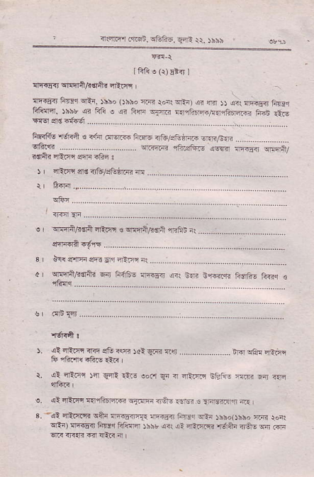
, it4F,r _{6irb.n.} ^{qfi1i6. gini} N. )bnb
I ^{6A e (r)} 5r-n l
!-Fqr EFlri/.a+{ er'F
_{{F{!=ir lirdq} ^{qFn.} rhhD ()sbo ]@ _{ron!} ^{qF)} €r _{m r)} ^{qm !F.r,} Ftur _{FL{n, rhbr} ^{q} Fiii e !i RlF ^{€'rc fr"irF,i4r.fiDrlffi} FBr -!.i€
_{FF<Ftu} ^{,[ffi} € ni? r,qr{ ftr ?f6,/,.ft:irc en/&n qft.r3.................... r.<sfnilrn ) iftn 3rn irtuls&rmB d
^{i. <i aAfl dTi eE} _{"ffi rat} ^{qR} Eqr ..........,..... ..... iiit !-@ iE;i tu ltoJl,q .FF ltR
{ ot irim )nr l-E r?F ^{e'.1} _{En ?} ^{qrlr,r']4} n'.il?r ^{-r"r} e- @
^{(i} _{4An} qnnnrr-@ ^{qTr;m.ln- zsn :} iF;]-crtr 4 ^{'al} _{{tT.4.} ^{qatn nF.EiFa} _{@a53i ftilr} ^{qft jsso(} _{rbbo} , bi r.ri _{lrtal} ^{qFiFn} 6Fr FRq- )b$r o< !- 4atu n6+n _{.,4!} ^{q} @
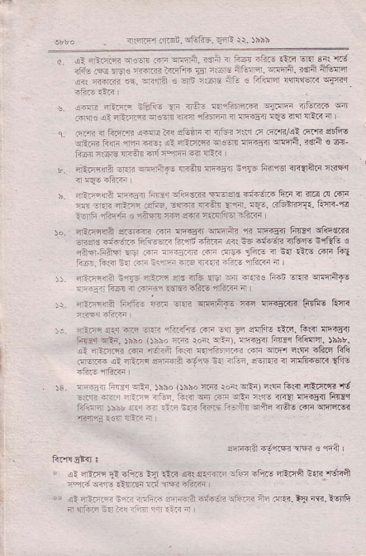
. arrr4 _{.r$.} ^{iiii-.} _{!n6} ii. )i:x
i rl ffi r -. r'F . si'"d _{{4 ffi !4. :n-,r;t . -in nlnr} ^{;ift} c li.air"n _{!!F?rdF} q{*'r
!. !rn! Ti@ iEFi. _{?i iN"- r-{rritffi} :-rFF _{lip_m} q _{Fris} ^{qa} _{r-Effi} ^{q.!r?} ?6 fi]F n ncFr !i- in fain a ' 1 FJB a to-i'r !ffi _{ri( sEliF} ^{q} .'itn n.j s @RFi .ii4r $66 .nF r'41F ri-r rEr 4t na|'.ii _{{.w n-in5?i} ^{qMn.} trqa € 63 _{ftc} ;is- _{'R?i in aF} ^{q} .-F
_{r. -ilF:?ri} ^{qfi} !Fni- 4?:ir iF65t iql]? nrifi @Alirn nsEq
F _{4F.r-{n} ri-5. Fr. !'Fc mqs -i6;R:n &!n { ilE F @li _{ar ?.i 46.;. .si!:. -lm} ^{qi3.} _{aq{.} !q-. nttiin'n.liE?-E 1-.i i?6.h . .nfl rrEi .fi r-iifi' atr n
^{j..} sR-Flra _{$.iffi ffi} ^{qF4sri} ilri? _{n aF..rl ftlrsr} slns|.r -rtup i:irqi Fnffr hrit <toF i( i? 4+@f _{4f6'r-} eql91i € ?nF i;il? rE rn n,r.-n rn _{4cn} ^{_,r.:E 4 dn} €e .m fil ^{q:.r.} ftia i. -.- a-iE -F -ffi -.,:rF f{ar - '
r niFlri_r _{lnTs i-r e:s.rtu ern} $1 T.Fs _{iF:E} ^{qni} $!rliF! , ra- rr@ 4 r41.1t@.tr@ rftnr
i\ ir.njra F4t- Er ffi erFe,F @ ^{nr5tu-Rn} _{FqftE} ftitr<
::. ^{-Er-} laq ffi aeF r-:--4iri n'ri ^{!?n} _{Jr-} sllfrc- riii- Ii<ir nrriEe _{Ffdr} ^{qr-.} _{rbho} ()hh' ^{'-.dr} _{ioil} ^{q-r.} _{"FFr3} lffir Ff(ffi. !hbt.
!t il.io? _{.{F} ^{'f,+j;r} 6s _{F,6r{a .n} ^{qm} irF itui fri .|.J@ !l itz ffiril +-dm srl ii'-. a:'R i ^{flfiEqF} 1FlE
$. ^{:r;i--} _{n-.rqqEn. rhbo} (Jbho r.{ rd;iqEi)ErFlis4E4{ird it.F -i.: -;,.. _{-,r-7. ?5} ^{q} _{r} =-i;li! irr{ !F.!rr Ftrnll Fffi :s;r ri.n - ri- i.F iimr i- nE rfti rA6 _{.dn} qJq1cr6 sri"n a.. _{1-.} ;
nmF]4.rE?6 4 sn
^{, 4r i-z} _{ll} -F- ir _{lirj} ^{qrr} eEr?i :1n _{r:iqio} ^{qffii} irf. {sffi ^{q.:} -E -]m ri:R ntuF
^{I'} a.4-.]n3--a-4-". n@A -.?in:':tra tF.r{3.Vft-ffi ₄ ^{qta+} _{t} -" ^{tr} ttta-^
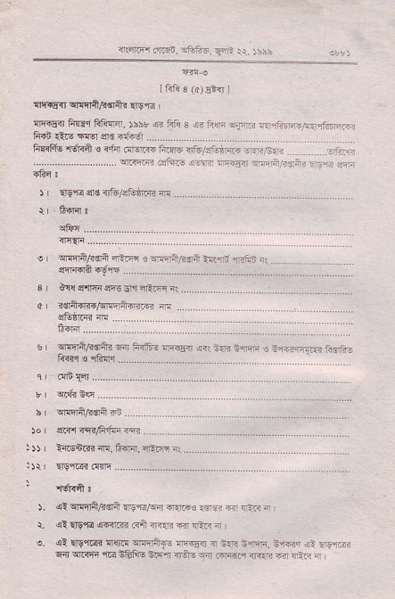
_{i} ^{q@} La.n ^{affa} rnri .. rs" r
Ifili,3 ^{(d)} E 'l
_{ari€{r} ^{q!fl4,6$i_r} ll9rr I
an s.i h'4rr Flc-{rir. !5br {r fri s ar Fn d_€rj irll,?rm/i?lE r.F ^{@it.ffidor......} ......
_{Fr?tft} ^{,rffi} 6 <"14 i.rcrF nm n!tu/366F ^{r4trnl} ..-j.o-.,:j i'7.?g--''1''
r tTqeodft ifrtti. ª ... ...
lBt
!sIE;.4c:fJ-_',.'5.:.:a-'ft.'''
3 | _{a!{ cf4F} qnj ^{grr} 4i@ i
d rd+ffi/{@ritu m
_{sr} ^{q*rn/hstu} Eij _{fRft-} qi+E ^{q?rnIR$,n@} ! cri.ErT.r; tisrli ^{q rnq....._._} __
ifiF+/.Fa'''''''
b iia @Ffr" G
:)) | ^{'4lnrft n.1@. -n-,.} ....
_{).} ^{(!} cllnftF$il _{esftr$d} ^{q{F!} .c-€ _{€ rn} ^{j} i
\ sl _{Ergi!} ,crFirm @tr 3tT{q < ^{qi<} 4
e. {l ^{qrgrEr} _{Tlfi{} ^{q!lA.€} l]qar{ 4 6a< e.n$. E <.i {: FEr.?n _{F{} ^{q.<nn '{@} iEl:rE liq.ri .rO- Tn tr{d.r rR.ri _{nr I"in} q
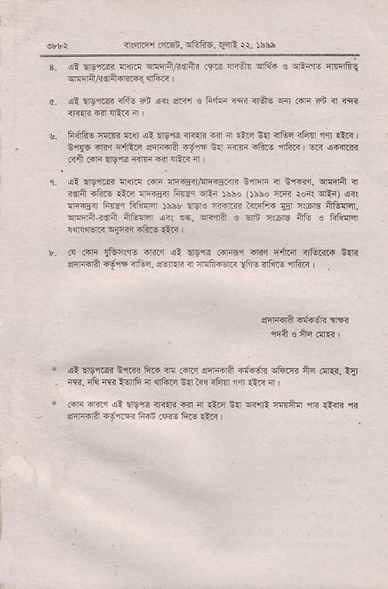
nrffir _{ftEn.} ^{qEf€.} sqn ri. rhs
s. _{al} ^{qg,r6:ir} _{nriil} ^{qfin/k€,in} _{lm m_.;b} ^{qih} _{c eii,l-} .mrfii! ^{qsliFdr+niai} !1fie
_{o. lt} ^{qrre} dj, 4 ,d. rF F4--.=?Fr'i"n. @
s. FfA! _{i{R !1lr} ^{ql} !'sn ir<rr? @ { _{i1F} ^{grl} _{4&n iFq} ^{jlcn} iL< _{ir{6 m{} ^{ptraq} sra.fi _{n-..n n.I} ^{'rm} -hF ifrr, @ @{rn ^{(?'i} ..F !r9 _{?E} ^{lFm} m {F.< i '
_{c.} ^{qi} wLdi lr@ idr {r.'54/E]qE!-,nr icffi { _{Effi1.} ^{qrdra} { i€ra r'riIl' _{ltf} {h?Eir _{hrsr} ^{3Ri} _{rbso} ()nbo ^{ii.{n} _{ronr} ^{qF)} <r{ n6sd Fcr _{FliaFr )hhb €9r€} ^{]-ilre a4iftr} _{Er} i@ nG@. q!ii'-rs;i +tuqa {+ tF. wirn € ^{q_rn} r$re ntu . Flim _{.n,r5.i} ^{qtFq} rh.! !t i r
_{b.} ^{({ .4F} _{1c"$-} ffi ol Ers.e .4-f,rir drr eir{l aFi?r{ 6.ir sF€? --..F ^{aEa 6rRn tr aqiidii} _{{n! r'tu!} ,llEn3
sT|@A rrfrii {F
^{,Fi?} e ii ora i
* al:re"rtrr n'rR _{&F n .ftr ffirn} ^{_{i#E} $riri +i ff.r. n{r <, nlir ir4 ?Elrfi ir di.i B.r ?i< <FT m :Ar a
. _{m} :F,r di rrsi! fiIIi dr ^{it} Q.6 _{ia} ^{q{1rl} F.a{ n ll'n r ^{qffiTlJ} dIF ffi ffifiF€F
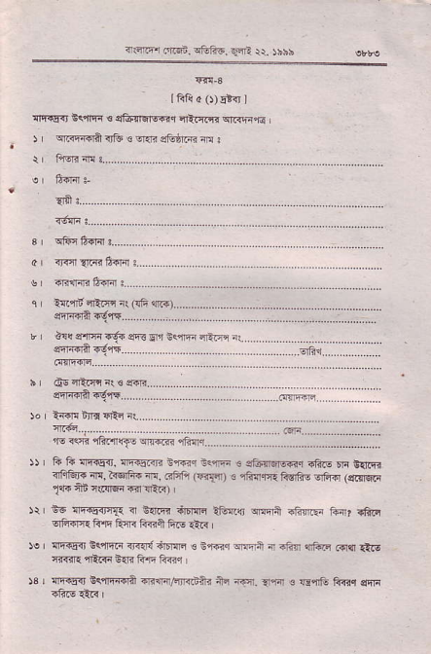
{.nrr r4Ei. ^{rE"ts. q-E} r\. rbbh
_{LF{d} (r)5rdfJ
^{q!r!i{r} G<raqr s sl=!ffil@r _{4t]@} q.qr,r6
) _{wnFrqn ir6 e} ^{q{i} etu rR n:
n!rn.?:..
la'fln nntE rr r {6 mr
'f.
t@ i-ir 6tc,.
^{r re-} _{"5..} i1o ^{l.rr@} fTq... ..
_{li 6 llF€ir,} ^{q(q.aE} iffi{ n1ffi € sft{6r@r rftE m Cftqi _{iiiGr.} ^{qF,} l{€rli+ N. Gt;ti (Fi{d) 3 ,Rnq6r fi-@R! Elfri (q@€ri _{$+} ^{q6} _{ns{qi} ^{rF.r} €F) '
i6 _{lrtas<tcI.} ^{q} ${.R ^{iE{Ic} _{l&{ar} ^{qEqri} iF]F _{i}a?} :!fi,F| 6G.|{{ Rfi fuR Fffi ftE €l<
{q€it tc'fi{-F rr.{r{ i6Fni ! Ef??r Imfr 4.-eA 4tun 6r{l €i6 _{F{.r.} ^{'nir.i} E{ri F.rr Gcq
fiFEnl E<'irrioit maF,/rFdtu iji ^{lq.} i.?1 € _{GqG k{rc} qF
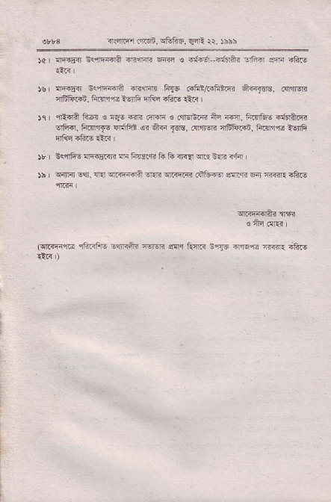
_{{(nl.fl fr?'qi.} ^{q&EE.} FE \. )hhh
)a | !|r€4 Bc'nEdiA -q.fini ffi s otrer--dErii oFd sii rftE
rs lrFilF B<,iFari drn'q _{ftF c.htnrftrnr *{r$rg,} (lrfw 'rtrFr.i. Fdlrr rrfr Ff€ ^{6?b} r€.. '
)q | ^{'rt{fi} F61I € tEo 6qr .trcn € _{.lnErsm ni} ^{l@.} ftT&E ififtqlr ^{qFid.} _{F.n'rf€} ^{qdFE @ €i{{} _{T€8.} (lrlrErll ilffir{!. Fitrrr'rd t6,fi
)rI Er4fi! rrFrEG'j F _{F{li.ft ft li TlqA} ^{ql.r} S.ri <.I4 I )b _{Fnir} ^{qQi.44 qrr@@a} _{EreE} ^{qnrqF{} ciFfgl 3fi.qr 6ir Fnr.ftF
(qnrqi{61 r6GFE lqjnfti iqEF ear turF $r3E ar6'ia 'tr{{l FliF €.{ )
^{{.{.i.rnFi alifio} --E rr /ibh
tfiii a (r) I'B I
drrEn B<{q{ € _{E6{E16r} qElq
_{r1r€i} jiFr ^{qEi.} rbho _{tJhio} :@ _{roni} ^{q-)} <? @ _{l)} ^{jzl} Firir Frrr Fftffi. )6br or trii ,? !i _{fi{i} ^{qffi q{r1FdftF.ii6Fr,ir ffi} its
?.h _{trar<5} i]f3 4ft _{njre} .a.g:-
......rd.tu&i:ins
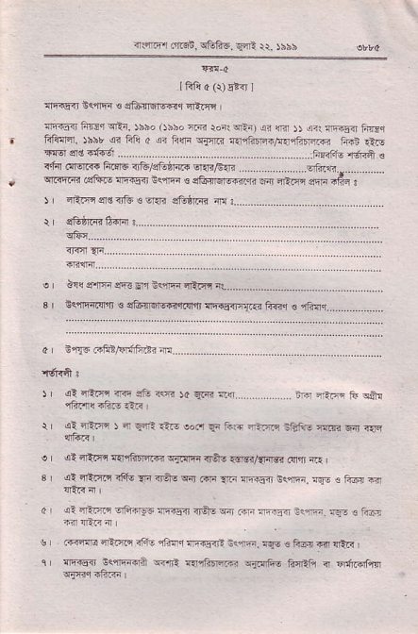
flFt&.3FT' ^{'-F6ET} _{'.fr a} ^{g+!'-.6@} },r ^{''IE} F '+ : ₎ ^{rie} _{de d+} ^{. ,E} _{e.-fr&} ,n
r tuBt6@.
^{r. i'.fFrl !%.1t1_411} ........
3r Eq,'rE{.qlr € ^{s16flqEiqr.$r'i nri45.r?.{ir4} fi@r € ifrr.. . ................ d' n,E rifinlrrlFdi d .....
) a! rrtF rrn' stu ?s ^{)o} _{4'R} r(r.. . .... . ^{.r:F} i-, tt ..iir
_{r} al ^{-r-rF r 4} E.rl €- ^{lof,} _{F} Ee i-r?j :r:G- ^{:l:@ EnJ} ".-q _{e} ^{(i} 4tfl E{rEiri@ ^{-ilffi} nA6.€B/{Fl3i ^{anlr} ".r _{3 al} ^{qE|lrq} _{{tu} ^{qn} _{ners} ^{q{ @} _{lF} lrF€i Bq@. tq! . fr@ n
₄ ' s? 4-ff -rfi4l--F {r{.sni _{T'e} ^{q.r} _{..,:F} rr-n ::"E. r- . tuF
u ..lilm _{rri@ itu} ^{,ilhr} rFs:<F ;eF. rqE ! tui 6 rirr i rrrs4 Bq11E€Pi ^{q{.rit} _{erft?ffi} qi.Te€ ^{ji{AA} i 6jt@t€
a ^{s.nr4} rrm _{-fi:i-.} ^{_r4i} 1r. rhhs
_{r|} ^{qr rF} _{/rdFiai} eirr _{-:.ri!F i]j4r 4t +affi} ^{qqe} .n !]'?Eir _{nqffi,4:iq} ^{q} {aF ni
h _{iqqfi!} ^{:ninsr{r} im,ns s{{q. !n . fli.f.q rF r_,t- rii4f.i 1ftfii 6i F _{l1.Fffi Tj.nii@ -6 rFFd} ^{.]ffi} e tu@
io lcqrri.,F wii !Fr.F _{F. $ cq !} ^{qiirFri} fr nF i lin $ _{!:rlq.} =r ^{t@} ".r,
_{rar} i<$65 ffi !Fi5r Frg.$ ! Fr.ft nil ?r!d rlrtt! $€r ^{f<q@'{6fai} _{1g-} f-/c 1in
_{)e} ql4riifir ^{q{a! fg'ol3 i@ iif.sm} _{FF} !r{i. F.i$ fflrs l31rn 4r'firr erF1q+{ FirlaT{i nre s{q i',iio ltln
$ crE{i{r hqfi hlim. )hhr oi FR ! ai ir-ER to) o nhliE 4tu m , sE*rn _{-,.+r} ^{qnr} fi{,r€ _{ftr$ rl artinm} ^{qrarlo} .n @4F4r A@ ir
)a al66En _{ftqEr} ^{qi.ff,n} _{o rai.€} ^{gld} Fiiri cF i iin F @F n
_{si} qFip. ^{gIrr q€oEG} isF6.
T!?16. Erffifi. is{F-
$h65'n ^{€ 6n?rr i'fliri. i,Frq.} _{?-€ilrr} rF. 6&irq. _{P.nd} .ro.rn.
"rir.
ft'rE. ffi r+.i trl-'r- 1fiFh e {,ni ffi irF ^{qFn{?} F a3E
)sr F iFo Frn F!6?s(r ai _{-r?,ff} ^{q.-qe qF€T} . 6.rr i1?ifi{.{i !r.6'i Rrr. E$rr -?- .:, '
)q _{4l crnffi riri} ^{'6} Ee @ rt i FtT _{-a} ^{;ic} nf'! _{.6} ^{o-i} n ffii FF iF @ Ai: {i,F $F€? -J,rF !-i irli-. a.r.!E a 'r:1irrF _{{"rcr""} ^{q} _{d m} ^{qEnEr} .rar d3 rftE 4,?a !i _{F} (ri,.! trlrn]I :rfti _{r.n-} ^{q (n} a-{ fiq 6 F1i] _{F6Fr{G} ^{'Rnrl} rq
^{enl;tr?r?!ffi -,."?} " r;a
Ri _{5F!?} ^{aftF} _{ll} r'i;iF !F a €F iii m.FnF trft-r i.@ {tFa ;-:r'ff1 rs-i wr- ..mF n n zr .,67j{!
** oi 4-ffi ^{i3.1r::6F} eF-ofi -i.iF lfrB is r{ri. _{:at} @. if, 'ii i-.i; , 4 Efl i? i.( ihir rn €.F 4 l
arli@ _{4't_5i_} ^{qFF.r.} _{r{5} \. )hbb
^{fi€n} _{1'fi} frcm _{r"R.{m} qir qr,.rii?
o 6{r"r s
:ri:...
T6rix.,,....... .....,....................
^{3r ccl} _{{r4r} E6Ia : .. . .... ......
o a!,:F- @ ^{*:-} ₅ ^{ryr..} ..
sE-dil #aa
! _{d!} ^{e$a' 'r} . @.
''''''''''''
ts R fr nF{r.r,trF€irF i@r ti.s{ ift! F -:-,rfi Tf6.n n. i@ti.{ ^{i1:'.} .iFfi (ri{{) { ^{qf€"R} Mre ^{-i-iq (?-FEi} _{r.-} ::i ^{'-iF} d lErO
_{br efiF €} (nqE ^{q} iE -{a e -@ nnF -r: ii- -?
ro Fiilm -{dt. ^{rtrtn? il€id} fri! lii l
^{-'' c-d.i} _{13-of:t} F!tr3-r. ^{r-5} rD&l-..a\.-"ri4 {.,, IllmT< alE ll1 wr ti-- ltri ,
_{)\ |} vtrni E$: {{ ^{qriF,ir?} !i.F ^{:lrr;mH} _{dft€ drF .-} ^{:-.i:r} "ftE € fti.lrf r
(qti;'ii ^{'ift<Fr- €li.{ni} mqr
sir f.I,z:r sff6 o1E{ 4{t.n Ffts
_{nlFr[Ei Fri6ii.} ^{qtufo.} E{3 N rxxi
I frli s ^{(c)} elir
^{1F€{} _{1E?'} ^{'i-d@} ii"r
_{lr.ianr FiEq} ^{qEr, )hho} _{Obbo} rfir _{tor!} ^{q€t qi} m )) lnt !€r$r FTdq FRqEr. )bbr _{sq Fft s} ^{q} _{ft$r} ^{qflr{} rnqhtR/rlirdilrl@ ffi €i! 5{qsnsid{6r.........................................................r!fir _{.ll6rr{i ft?r6.f6lstd,li1i} 6R]?/6'{i -'.---.. .vlF?1l............... ^{qnrqrn} .cft.G nrF{!ir] Fq ^{ts} $? 1iffi w Ei.iF eqa .Rq : ^{q{r} dl6 air. ª r.. ..... ...... ...
!t-r.r' tr.r '
^{qii".....} ..
^{dr,{i....} ..... ...
^{d.! ffi ft} _{5_} d-r {.
_{lE{} F6.1ri _{6r} ^{qF€<r1::.r} 1i{rr _{c} ^{qe'lfiE rfiqq} _{{di6ri} 4- l3E€+n r 6tt'q, .... ...
3"Fo;4rcn.tre.in:.
r | ,ql lntr"r _{<r{} ^{qG iq 50} _{E@} dtIt.................... tm 4im tu fiir _{si:rF.rq J 4} ^{qqe} _{lle oo.r} ^{q{} ftrir 4ftn nff6 nEa? 6i, r{r
qi qR.q q{rfrfi{d ^{qj1{ld ir+$} _{€roi,?r@} o,]] 4.r r
^{qe} 4trrr ^{rfi$} _{?li ir$s} ^{qii G'ri} _{lrF} !rq.F<r {qE e l?@ Fir !l!t< 4r
^{dEtE} _{d6El.F ?tr} ^{'tai} nlF i4Fffi<rFi5t@o.
_{4:rrlTi} ^{qfti qFdlir} 6! _{a} qEr< q
_{a!} ^{qrimr} _{ifff6} ^{q(€.r} _{irA-} ^{qn} m r@Eir @. {qs ! fn6{ r'ir @{rrr! cFtrfi ifio clinr !rr'€{R lqo € F4a iFr {ER ,
^{ilrrrq} _{rcn6n,} ^{38F5,} _{f4E} $ )!i5
r _{,el} ^{qE@} _{iGfF sftin} q+6 qd ^{(ali} ntu rTir'5{ fto@ m.FiE
b .{rn 4Fn {rtrFit rtrF6i -hF rft4 4EFi eF,iril i-..,ta ^{q4qqi@} il{F L.i
^{jo} _{I} ^{ql} cRnl4i ^{sR" EqsfE r'q<F i} _{!fr} ^{qetrr.} F.r. iqr- _{ftlir} q"r{'<5i !e{r? i]1mi sffEntr ftirct]{n iii? drq sftr 1lF
ir I s4{6 SFq.€{ _{<rraqili} ^{qh{} _{.{i rift n} ^{q.F qbfrA"} _{tut iras} qit _{iFlr€ liii} ^{qi qF.ffi qitn} @ n€{ fi@ 4 €rF n nti 4 | )i iTr-rEql fiTdq clirsm .{ ^{(in} +r€r ere d€ft6 fiF ir @ F @ 4 _{nl} ^{qEm.} b{i cr€ELEF ^{(gFq.} {]c:n- _{rF} ^{qr'rEi]} c@n. fraitr !r6r'1E, {ri,rm{r, 4r{,r< -onfi r?r'Fr-ffiilF. rFqfi ! !6rl {iF ari6 :rF.flq? :F f8 a.ritq iftF
)e _{| fiiftt} ^{qi!} _{Fli_!ff al 4a.ffi} ^{q6Ao} s+5!]qT:{. wAi' F:nc
!3' .q.irturliitq4rl,ieif.tu ffift"nqlii{ni'53r&@{irnlRa I
)0 | iq{6 Ff4q.n s<{{E et- i@tr irAE {frlar _{..ft} (in qqtor Frarc {rFiv{ lior @ {E.i a
)$ a€c r]<{rs< dr 4irfl{? f.6{ n.{,fr .ft! at<
_{)r,} ^{q!} _{s'::ft4r .rF} ^{'rd} Eti 14' trn 65r l{i nfts _{r!F!t @} ^{qFi} 4 fi&i _{Fn} ^{qlF} {ir _{rtq} ^{qE:fl} a{6rA a'e:F En <rtun. r€rFr. n nturq,.? _{lfn@q-r} ^{qir} _{n .{fi} ^{qEnlr} <r€r arr .BF _{{hF I} ^{qi} F aim _{ft6fl!} ^{qriic} _{irA-} ^{qr} 6F rr.{r @r a ii$ _{!rEF.6} ^{'rldri} r€{r
sfl4fi? f6.,rcFi
_{arB €} .1!n.r
f.! EHt ^{nF.€} _{ri} 4ftF elrn @ raF ai1 _{arr.lF} ^{qlir} _{iftrs} qEl:f4 s.r!'rffi:-dwi- a1lrzF {.{'m -toF
,.* . _{d?} ^{qt:.ffi} $,rE rEfiR sir-d? ituR !tun ils tr.r. ill 4- rlir ffi. ffi a ?r]ftn Ra a<{ iFfl +r _{ilr<} 'n
!Ff€c, <r{{rrr w r1nft6r vfiFt I
₎ ^{qrrq+} _{nk. L::../} ^{j} ,:..
r| _{Ga'4,@} E.'5 ' .-
! 6@,
ar td,'r-!.
^{-i.} .... ... .. ..
-&f.'4-"'4ft41|d..'c"''''
si ^{rh.;} "
_{at {@:} ^{,;-t ;.} 4". !1",
^{(.l;r@} _{?F} ili <4.? ri'
r strir.r ftdft- Gii5in r{ad. Ff+rre drlie € ctu:}ln ryiT< r@e s...... ..... .. 'r. ^{F} _{1?d} ^{si} "-€. .-
_{hr a} 'rTq !lq45!r nF{lT1sT _{i]tlF} ^{'ffirB} ${.4 ifiGF fi. k€rFi{ nr!, _{.?Ffl} (Eiril e 1fi{,re FeF! c]fia ^{(e4r6ri} _{T|6} flB r,rrr @
_{)o} ^{q4l-,} _{-q:} ^{q.} llffinin _{1_!t} ^{qri:r@} dji@ @fr n ffi1r-fo6
' qiir@itr-,rrFi!
nEfl{ir
!{inii rEiri 3!r"r Pff _{;1116} ^{qf<,r!} *|T{a ituF
^{q} r-q .lrcE. rtah r.lqr- rt. rihb
IRttr(r)E ol
tri+5it _{fttrs<r} ^{qEr. )5bo} _{osso} ^{c.ij} _{ro(} qF) ^{q} 4i _{s} ^{q{i} !Fir4 FqEq _{tr!:rrir,} ^{jhbr qi} Fj! _{r} ^{q} _{Fs} ^{q_ffi :laffilFF,{fiFirrr} fiFn ^{€FE6er€.trfer...............} , . ... . Frafft,N*nr+ €<f{ dEr..4 ftrfftr <ft/eftdFl" ^{qqi/ftIr} . ....................... irA.E !r,ll@ @1+rs llr.sa {r<{rTr Ex rFEd alrr +f1ir ,
) lrqfii 5o ato o -ir. !fts@ ft
ol T.fI' @ s& <qa ra qB lrq ..... .. .............. Rrir n1t _{fi} qAn rFmq.EF rlrr
_{lsr} ^{q:rF} itE ao.r qn r& lisr firftr nbiG ^{:i]@} n- a- nFli 4{F
_{{.rrE6rqi'€} ^{qrisF} _{rie-} ^{q?} {RFi {qrtn'{tu o!] -.q I <i ^{fiftn !€F!} ?ri reE s{ F6€ @iin nq! ii<{ TFrE dn vEa
4iM {irs< lelF F:4 erfa ffial ml:'oni.{., _{ol} ^{,nftd. q&i} ir.fillrii m€{ 6r € rEri i ,
_{6.flE 1riftd} ^{qlillG-} ffilr{ _{rF€ir ir@} ^{q} lPj l
ai rraFin iffi€ 66rffi nirr@ .r€li ^{qnr} rcirfi- ^{{,i €} rqrEdri _{irq-} ^{q{} _{.ra} ^{ql} _{rFFftnr} ^{q€!IFE} lFiFir _{r.{.I? -F-i!} ^{,fifn6} rj ,
4r4F r diqn, _{s6i€.} ^{qqF} rr. sbib
-
b fiF _{4" rl} ^{-"ic!} _{{a'\a'tfd6} * a ^{@s'f} _{"r@} -a a ^{qftE} e{d{ft _{i'":rrn} ^{q{nrr@t!} stuE r-F w ^{rrdd} {6'irnffi rf@ _{dtr} ^{q{r4rF q.nF} €.< n
)o sl _{4lihd?} ^{qc-L6 !rr&q n{il} _{i€} ^{qaTl.} .nrF _{i€q. f.{a} qr{F.n _{.€{E} 4n{d ern6a! F4re1fi iF!r.I.{ ^{ift65} _{€t1} '
rJ _{I} ^{q@tr} _{66qri} ^{gR'lr} _{{trlw,ftfti} -rfti5r-.G $fi .{lfr _{iio's} q.n -r{r€ _{$ri} ^{qi} _{|riFdr} ^{qr{orlv} 8.5<r firl ir 4itR _{6r} ^{qEn} 4 )r nis4 _{F-!{i} ^{qJlrffi} m .dF _{ffi} ^{q€ iff6.. &6} _{"r} ?@ @ .dn rq
sl cnFn. _{s.?} q@EE
_{fq!} ^{qF.5<r.} _{1i1dr..} drqcr. iiftql
^{-lr6r,fd.} -rrrmr. a:lb+F trG r?s-l-rftq- .fin-ft € ^{{ti "ETi} ffi _{3ffi} ^{q.rllfila} eili 4*.- €R I "n.
ro I ftiiis!r{.qhdi€-lRai'ididrqccrgEqFiFi.l3ftnii.5q$F65
)s _{r} ^{q? 'llift&} _{..F} ^{,r;} Etr -4r €.i iitir n.lr _{cta6 nf,E r} ^{qEn} ir FFF lilri n1qr Fir ri.i iErfl ^{eiriaa F} _{.f} 6{ a&-. ereFfr. a{F]rGrrr _{?ft@qil} ^{q?l} _{rq ({i} ^{q,i{i,j} <,ii d4 ^{-1i@} _{"flF.n} I al .nI a4{E _{ft€lfrr} qftq q6- qar ^{(@} <,a{ 6Jrq rir _{Ernr} ^{qF4.en 'E} nri ft{
^{q-rr4la} T63'F" aE € n" '
^{F:} _{{r} sa {ifri _{!l} -Ae sF 6 _{€,n} {{ _{a1iiriE} Etun _{.F]rE} 'nifiilrn &.]? ^{'lffi i-rdwq-} _{*.e.{} lrn ffi ifto
^{+? (!} {iliiE? tm o ft4 si-4?rA _{Ftur} ^{qftn} nn €{i. lit ffi, iE e- ffi _{n} ^{,ituF} nn _{iil rFlr rri .tl} q
alq'crr _{.'isi,} ^{q6fr-6. qqE} Q. )bi5
IRft $ 0)!'n I
_{{!€n} qr/1ftq.{r rr;R ^{in} _{s} ^{qr.rF,f{} |
_{r'} frrrFi n _{a} ^{il.?} ! ......
, ^{rf:t} rFqa _{F.iFt} .il.r
3 c {-tn . d'b? iat ^{zio :-E€na} @ _{!"-} ^{.,tra} @ Eq" a. _{6n.} ^{qF.t!} r. ^{€ nrr.Elt} fm.l ^{of!q@} ii-!q@ m ,
o I rq !fti 1?@.f@ ^{rf4e} &r 6{i n € 6q |.. ..
e ' r?.@ fn. ^{Tn :..........} .,................,,,. .. ^{qr} rBr{.i! rERr i{f{lr u ,.,....
br rF{{ri:RfF{IA rtb/qehr{{ {c € F$m , ............ ...... r. | :e1!{ {{fi! ar< fi{'€ llq Fnrr.i € 6 d?q,r lrr{ir rliiF
_{)r} ^{qrrir} lct _{!r{} qrrF{.ja q{n ^{qrfiiR} fiTFrsl cqffi{ 6{ rnne $l?F rlr{r | (cn@ _{re} ^{'ifr.?il|!} cqrFiii cErEr. sq"r turR !{c6 .nqrrc
^{irnFr Lt6R. ft1-5.} FE Q rhii
IRiib (r)E {rI
rrr-q{ @ {r _{ltF} ^{q} _{{.r} {:n/rli{{.fr 6ar ffi '
^{qrrsn} _{FTr.r} ^{qEi, r$o} _{llhso} ffi _{ror,} ^{qFi)} !F _{{in 5r} ^{q( qF{..i} IiFq fifinla. )66r _{<i Fft h} ^{q} _{FF} ^{qrtr} T..fi!m75.r{iffi irii rle ]@ c1€ r{frgr .................. ............................... FFifin'riiil € i.lnr .!ro.@ _{ft$6} ^{q&/} _{stusrnii} ^{q{r/ E} 1r . ........ oftin lr&qFE _{@ja3} (qrir ^{q!.5{} <./ ^{'i1i{?ri qn, '1rr} s4 .F-i .
JIff'*-l'''
r. riaFn s5F I
_{r} ⁻ _{?r} '-.E.d 4r<fai -1r
nz? ^{.aF,} .. ... ..
3 F F rl5€n 16',nf 14 .i.n 9iriF FdFs E''nr c .liar ({l;rlqi n- i{Er.& ft € Ffirllii:) r
d a atiri 4 {Fr liii .iu- !]!.Ft ri rinir sr"l 41i.- rle sri N € fida ; .. .... ....
_{-('"} ^{i} "
'Ew, Fn. /&m ."
_{el c} ^{.rF} 6rF dir o{'. ,t?tn4 )44
_{e} 'tu.ra' +B € ^{qr} t
r _{@41} aiF.n.eta...
'rffi!
₎ ^{qa qr} Idrdrall'lr i.. r
\' (l ^{,ir} o- 3rm .dr ir.a? -{ TEF - I
_{o a?} ^{rill} F4€s fl.lri !r!r ?rr{r ?lr;n €.r r]Ei itur,J$ iil< r ^{i.r4" '+Eq} eilir lirrln +-y,rF in T<rF.ft- _{afiF w} ^{(lllm} Fn ^{qtii1} i?rF -{ {rlti 4r
_{s} ^{ql} crG _{rfii} ^{.iliftq? qlti} a{i5Eir rii{<' a {F.q n
_{TsiFr dtE!.} ^{q8f'5. qi-:} !r. )ir:s
_{a} ^{qt} _{rrin!EA- afthi -ia-} ^{q} r',*c ft4;:iF iriF.F Tn{{r nlnl $ I drisGq rhi.4dA.ie- {r rit _{ei} ^{+iF} -fl:r{- f,Firjr rft{5 .fts
^{q} _{rit{.ffi} In4?!ffi tFi _{!:F.egr. ri} ^{.i--.#} 6l dr ! S.n ^{q€srlFllrfn} drr if,fl .'FrF nft.ri.
rr 4r .nn irT6 ffi _{lir.r'li} r:-eF rr f <FF iiie 16F r
rfi{r.qfrE"i-qei4 s7flft agn riar* Er6r$€rfrYlr 3 ti.r'(i{r
' c!nl-r4korTqs !@ r'.@m {+6 tr*a dr ftriir{+'A sefim ffi 6tpetr +f"r Wl i'!ffi lid rlliR * n crl sr'.i m ft" _{er.n rJ. nffi} ^{q',!6} Aq 6I{i. ^{ali nti.} !t i!q, tqF f, _{rrai-} ^{'t} _{r} ^{>a<} ?,_ ^{1,} 13r
1frft s O) 5i-{ 1
ni51r ftftnric.ftr ftnl.{1cn :
1lr<!a isrffi _{Rfrar} rFn r
lFli $ O) E*r I
{F5a {ftft ft6.{r lirli{i @ !
^{rnrirfl} _{c,rzEn.} ^{qGF6. q4i} Q. )bh$
%
lFli $ o)Eh I
tr'it6rt8'F. Ff+ Tr{{-{T rF<nt Rrlrd Ed\ u
InA ^{I (J)E}rr} I
^{!ll_q{r} lrrl F-6!Tr Rnld rr{.

